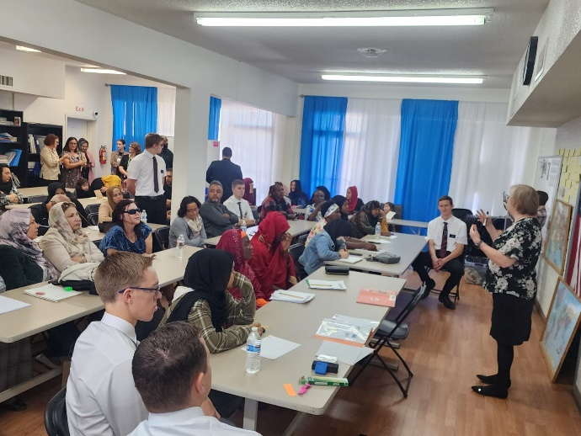
Before April of the following year and receive a FULL TAX CREDIT when you fill out your Arizona State Taxes. Arizona law allows you to subtract your donation from what you owe to the state, so it’s a WIN-WIN!
Your Arizona friends and family can donate and get tax credits too!
Please share a copy of the donation form with them.

You can bring the tax credit form to our office, or you can mail it to us or you can use PAYPAL online. Simply complete the form and send it back with your donation. This is an easy way to support the newly arrived refugees in our county. Please send your donation before April of the following year.

CURRENT TAX CREDIT LIMITS
Individuals: $400 Joint/Family: $800

The Somali American United Council of Arizona is a non-profit 501 (c)(3) Qualified Charitable organization within the State of Arizona, whose mission and vision are to facilitate and improve communication channels and contribute to the well-being of the low-income multiethnic Refugee/ immigrant community, assisting them to achieve self-sufficiency and in becoming productive law- abiding citizens that can properly integrate for a great patriotism. SAUC has earned a reputation for delivering sustainable, uninterrupted, noble and honest services since 2006, and for acting always according to the highest professional and ethical standards. Your donation will help fund activities right here at the Somali-American United Council of AZ for:
•Teaching supplies •Tutoring after school •Field trips •Youth Development Activities • Job Readiness & Job Placement •Women Empowerment and Self-Sufficiency programs •Preschool Services
If you would like to mail your donation, please be certain we receive it before April of the following year.
Mail your tax credit donation to:
SOMALI-AMERICAN UNITED COUNCIL OF AZ
2425 E. Thomas Rd. Suite 11,
Phoenix, AZ 85016

HOW DO I DONATE?
BY MAIL: Sending this form and your donation to the following address:

Somali-American United Council of Arizona
2425 E. Thomas Rd. Suite 11
Phoenix, AZ 85016
**************************************************************************************
Payment Type
Filing single – Amount of Donation (up to $400) $_________________________________
Filing jointly – Amount of Donation (up to $800) $________________________________

Please Print:
Name _________________________________________________________________________________

Address _______________________________________________________________________________

City/State/Zip __________________________________________________________________________

Phone ____________________________ Email _______________________________________________
Make Check Payable to Somali-American United Council of Arizona)

Tax Year: _________ Donation Amount: __________________ Tax ID: 01-0876916

BY PAYPAL ONLINE: Use your credit card to donate through PAYPAL using this link:
Donate through PayPal

You can also visit our website: Somali-American United Council of AZ

THANK YOU!

